**GREATEST NUMBER IN AN ARRAY**  
  
**EXP NO: 7**

**AIM:**To find the largest number from an array using 8085 processor.

**ALGORITHM:**   
1) Load the address of the first element of the array in HL pair.   
2) Move the count to B register.   
3) Increment the pointer.   
4) Get the first data in A register.   
5) Decrement the count.   
6) Increment the pointer.   
7) Compare the content of memory addressed by HL pair with that of A register.   
8) If carry=0, go to step 10 or if carry=1 go to step 9   
9) Move the content of memory addressed by HL to A register.   
10) Decrement the count.

**PROGRAM:**   
LXI H,2050   
MOV C,M   
DCR C   
INX H   
MOV A,M   
LOOP1: INX H   
CMP M   
JNC LOOP   
MOV A,M   
LOOP: DCR C   
JNZ LOOP1   
STA 2058   
HLT

**INPUT:**

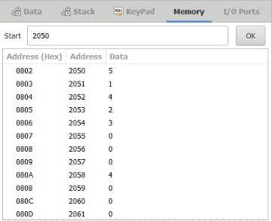

**OUTPUT:**

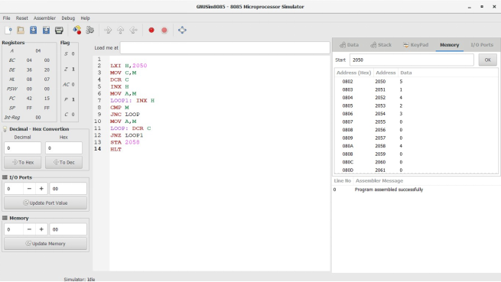

**RESULT:** Thus the program was executed successfully using 8085 processor simulator.